# [E109]_[E110] Hop valves 3-4

At first, switch on the machine, select the service menu and open all the valves. (valves can be removed only in open position)

The hop valve No. 3 and 4 can be found at the indicated area.

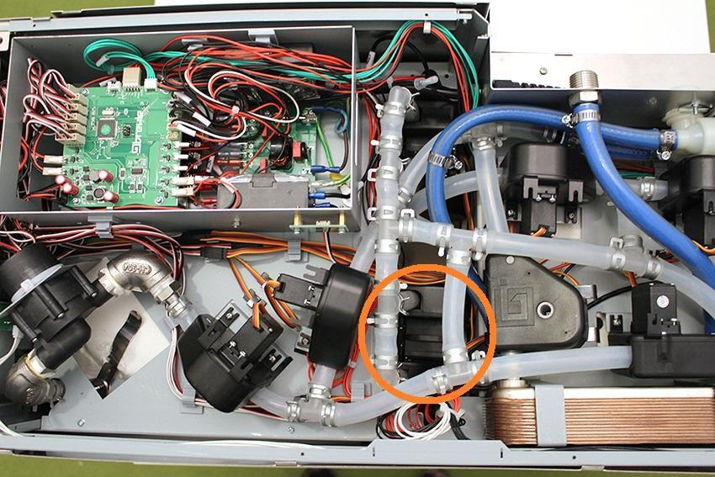

Pull off the indicated hose clamps and silicone tubes from the fittings.

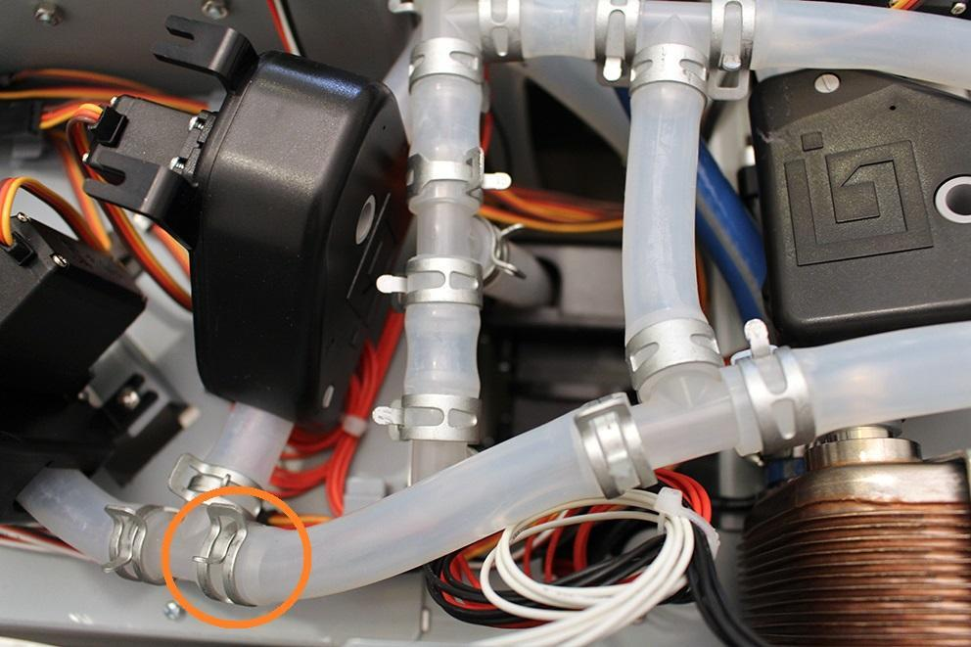

Pull off the indicated hose clamps and silicone tubes from the fittings.

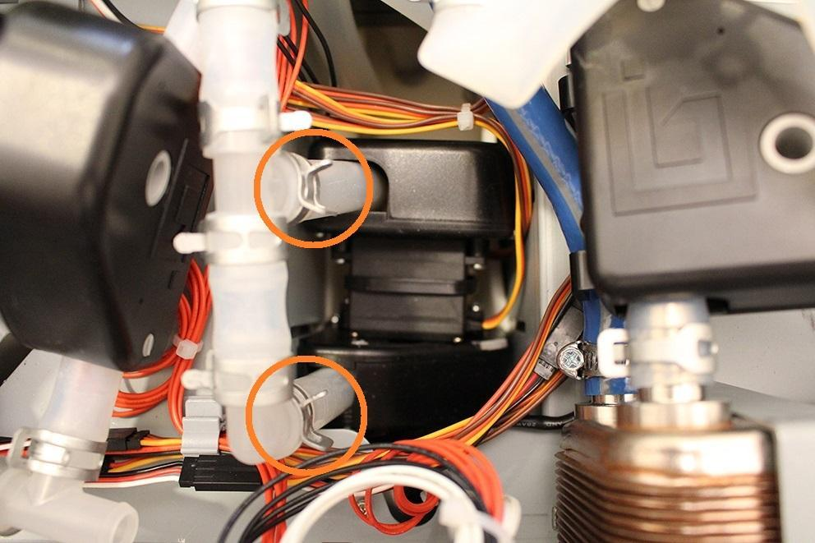

Remove the indicated hose clamps.

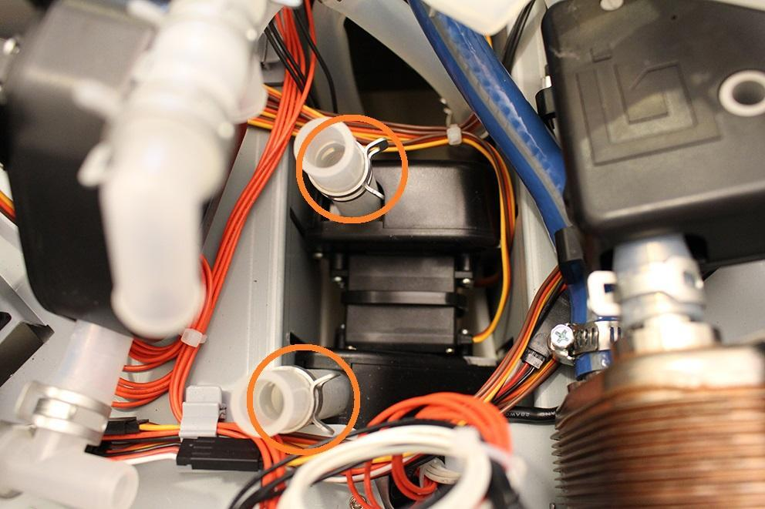

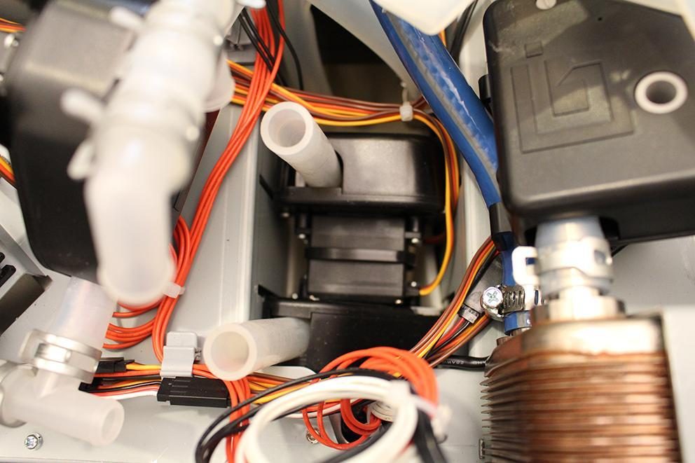

Now you can remove the hop valve 3 and 4. They are fixed together with a cable tie, so you have to cut it.

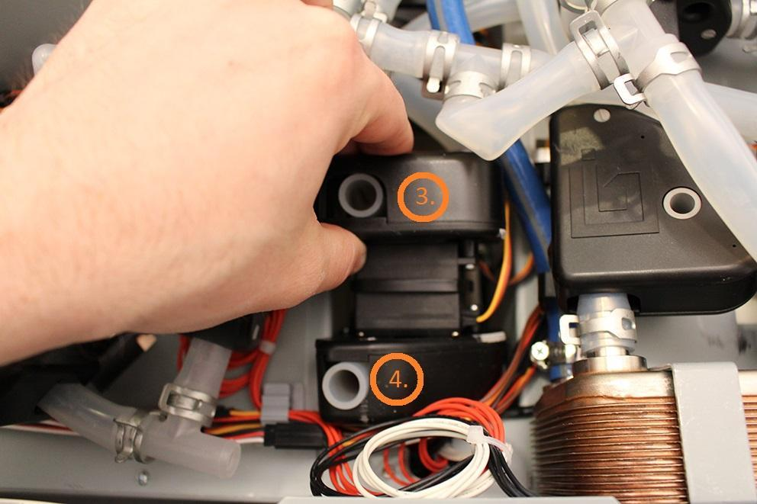

Disconnect the plug of the valves.

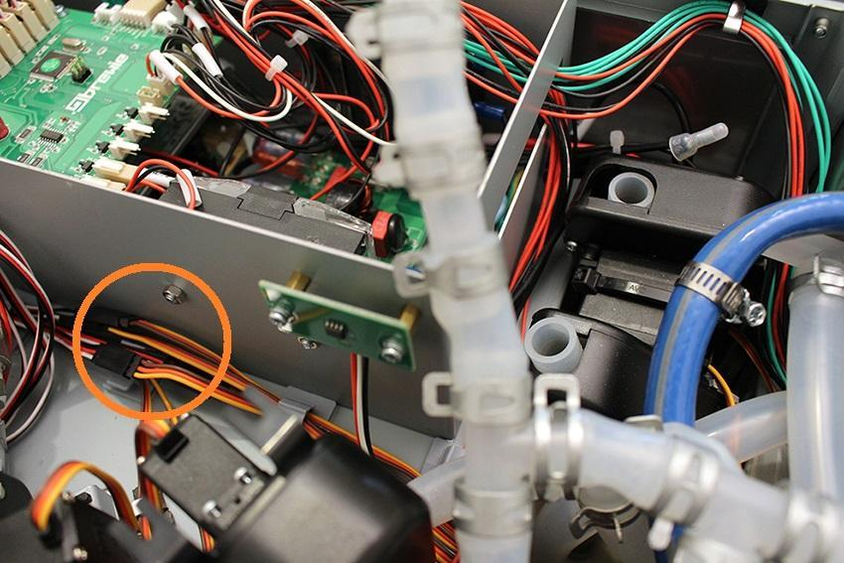

After you removed the valve, please check if the inner wall of the silicone tube is clinged together. If it is clinged together, do not change the valve, you only have to do is to separate the inner walls.

Reassemble consists of the same steps in reverse.